Experiment No. 2

Matlab Code:
clear; clc;
N = 1e6; % number of bits or symbols rng(100); % initialize random generator
ip = rand(1, N) > 0.5; % generating 0,1 with equal probability s = 2*ip - 1; % BPSK modulation: 0 -> -1, 1 -> +1
n = (1/sqrt(2)) * (randn(1, N) + 1j*randn(1, N)); % AWGN noise Eb_N0_dB = -3:10; % range of Eb/N0 values
nErr = zeros(size(Eb_N0_dB)); % preallocate error array for ii = 1:length(Eb_N0_dB)
y = s + 10^(-Eb_N0_dB(ii)/20) * n; ipHat = real(y) > 0;
nErr(ii) = sum(ip ~= ipHat); end
simBer = nErr / N; % simulated BER
theoryBer = 0.5 * erfc(sqrt(10.^(Eb_N0_dB/10))); % theoretical BER figure;
semilogy(Eb_N0_dB, theoryBer, 'b.-', 'LineWidth', 1.5); hold on;
semilogy(Eb_N0_dB, simBer, 'mx-', 'LineWidth', 1.5); axis([-3 10 1e-5 0.5]);
grid on;
legend('Theory', 'Simulation'); xlabel('Eb/N0 (dB)'); ylabel('Bit Error Rate (BER)');
title('Bit Error Probability Curve for BPSK');

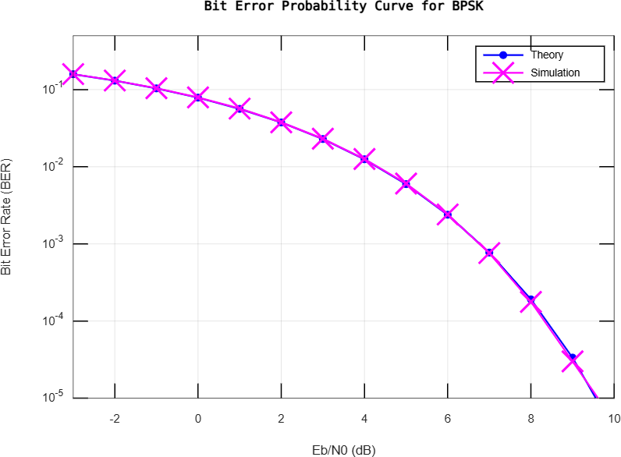

clear; clc;
N = 1e6; % number of bits Eb_N0_dB = 0:35;
rng(100); % for reproducibility ip = rand(1, N) > 0.5; % 0/1 bits
s = 2*ip - 1; % BPSK: 0 -> -1, 1 -> +1
nErr = zeros(size(Eb_N0_dB)); % preallocate for ii = 1:length(Eb_N0_dB)
h = (1/sqrt(2)) * (randn(1, N) + 1i*randn(1, N));
n = (1/sqrt(2)) * (randn(1, N) + 1i*randn(1, N)); y = h .* s + 10^(-Eb_N0_dB(ii)/20) * n; h(abs(h) < 1e-10) = 1e-10;
yHat = y ./ h;
ipHat = real(yHat) > 0; nErr(ii) = sum(ip ~= ipHat);
end
simBer = nErr / N;
Eb_N0 = 10.^(Eb_N0_dB/10);
theoryBer = 0.5 * (1 - sqrt(Eb_N0 ./ (1 + Eb_N0))); figure;
semilogy(Eb_N0_dB, theoryBer, 'b-', 'LineWidth', 2); hold on; semilogy(Eb_N0_dB, simBer, 'rx-', 'LineWidth', 1.5);
grid on; xlabel('Eb/N0 (dB)');
ylabel('Bit Error Rate');
title('BER for BPSK in Rayleigh Fading Channel'); legend('Theory','Simulation');
axis([0 35 1e-5 1]);

